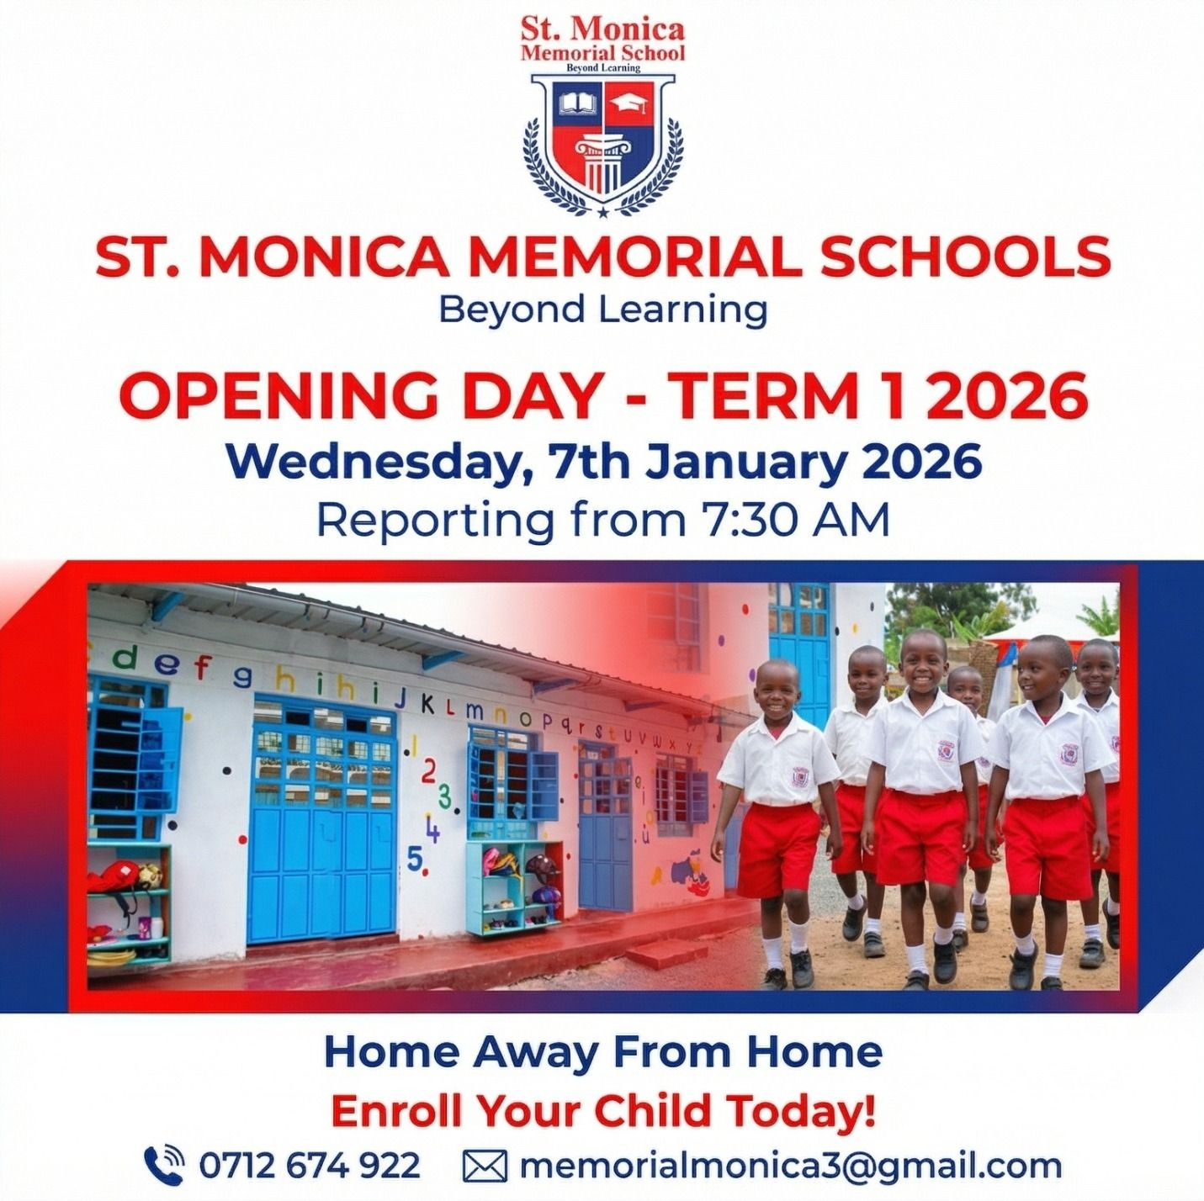
Admission Policy
The admission and enrollment for private Kindergarten or Early Childhood Development (ECDE) center is set by individual school managements while complying with Ministry of Education guidelines/policies. Policies typically require children to be at least 2 to 3 years for playgroup, and mandate a birth certificate, immunization records, and a completed application form.
Age-Based Placement Guidelines
- Creche: 2 to 3 years old
- Playgroup: 3 to 4 years old
- PP1: 4 to 5 years old
- PP2: 5 to 6 years old
Core Requirements and Documentation
- Identification: Copy of the child's certified birth certificate and parent or guardian National ID cards or passports.
- Medical / Health: Up-to-date immunization card and a medical history / fitness report detailing allergies or special needs.
- Assessments: Informal developmental observations or friendly play-based assessments for older Kindergarten entry levels.
- Previous Records: Transfer reports or evaluation letters if moving from another kindergarten or daycare.
Financial and Administrative Terms
- Application Fees: Non-refundable administrative or assessment fees charged prior to placement evaluation of Ksh 2000.
- Tuition and Levies: Clear terms on payments schedules (70% of fees before or on the opening day; 30% payable second month of the term) levies for lunch or transport and uniform requirements.
Re-enrollment / Continuity Admission for older students is given upon successful completion of an assessment test. A non-refundable fee of Ksh 1500 and previous school report or assessment results are required for assessment test. Following the assessment, the admissions office will provide an application form together with the fee structure and reserve a space for your child.
You can call or email to arrange a school visit between 9am to 3pm Monday through Friday and Saturday 9am to 1pm.
School Fees and Payment Policy
Our fees reflect the high quality of education at St. Monica School (SMMS). We invest in exceptional teachers, high-quality learning materials, and a beautiful and well-maintained learning environment. This ensures that we can provide an outstanding education that supports not only the academics but also the holistic development of each child.
Payment Terms
- Payments: Tuition fees are inclusive of lunch, all art and handicraft materials, games and music equipment, stationery and all approved textbooks and exercise books.
- Fees are payable strictly before the start of a new term.
- Payment can be made by Mpesa and direct transfer to the school's bank account. Strictly NO CASH.
- A mandatory annual fee of 1500 is required per child for medical emergency during the school term.
Discounts
- Siblings' discount on tuition fees will apply as follows: 2nd child 10%, 3rd & 4th child 15% for sibling attending school at the same time.
- A 7% discount is applied to the full annual tuition fee if remitted payment is done in its entirety before the official start date of the academic year.
Withdrawing a Child
- Parents who withdraw their children for leave or any reason during the term are liable for a full term's fees.
- A full term's written notice, with the headteacher's written acknowledgement, is required for withdrawals, otherwise, a full term's fees are payable in lieu of such notice.
Co-curricular Activities
- Co-curricular activities are optional and charged separately.
Fees Review
- The Board of Directors reserves the right to alter the fees annually with at least a full term's notice.

